|  |  |
| --- | --- |
| **Name** | Muhammad Asad |
| **Reg. No** | 2019-EE-383 |
| **Marks / Grade** |  |

**Electric Circuits EE(100)**

**EXPERIMENT NO.12**

**Equivalent Capacitance and Inductance Measurements**

**Objectives:**

* To study about Capacitors and Inductors and their method to solve in different types of circuits.
* To explain the energy storing capability of Inductors and Capacitors.

**Equipment:**

* Digital Multimeter ( DMM )
* Bread Board
* Inductors
* Capacitors
* Connecting Wires

**Prerequisite:**

Before coming to the lab, students must know about capacitors and inductors and how to solve them in different types of circuits.

**Theory Overview:**

**Capacitor:**

A capacitor is a circuit element that consists of two conducting surfaces separated by a non-conducting, or dielectric, material.

It is an energy storing device.

**Capacitance:**

“Ability of Capacitor to store charge is known as Capacitance.”

C = Q / V

**Unit of Capacitance:**

Unit of Capacitance is Farad ( F ).

1F = 1C / 1V

**Inductor:**

. An Inductor is a circuit element that consists of a conducting wire usually in the form of a coil. It is an energy storing device.

**Inductance:**

“The property of an electric conductor or circuit that causes an electromotive force to be generated by a change in the current flowing.”

**Unit of Inductance:**

Unit of Inductance is Henry.

**Capacitors in Series:**

If a number of capacitors are connected in series, their equivalent capacitance can be calculated using KVL.

v(t) = v1(t) + v2(t) + v3(t) +…..+ v N(t) .

vi(t) =( 1/Ci) + integration t0 to t (It) + vi( to ).

v(t) =( 1/Cs) + integration t0 to t (It) + vi( to ).

**Equivalent Capacitance:**

Therefore, the equivalent Capacitance of the circuit in series combination.

1/Cs=1/C1 + 1 /C2 +1/C3 +…1/Cn.

**Circuit Diagram:**

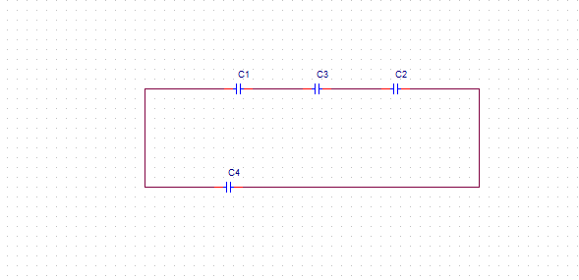

**Circuit Diagram of Equivalent Capacitance In Series:**

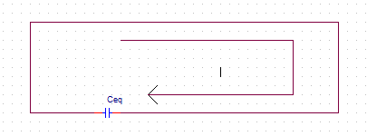

* When capacitors are connected in series, they are solved like we solve resistors in parallel.

**Capacitors in Parallel:**

To determine the equivalent capacitance of N capacitors connected in parallel, we employ KCL.

I(t)=i1(t) + i2(t) +i3(t)+ ….+iN(t).

=c1 d(v)/d(t) + c2dv(t)/d(t) + c3dv(t)/d(t) +…cNdv(t)/d(t).

=cp dv(t)/d(t).

The equivalent capacitance of Capacitor in parallel.

Cp= C1 + C2 + C3+….+ Cn.

**Circuit Diagram:**

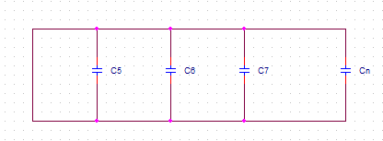

**Circuit Diagram of Equivalent Capacitance in Parallel:**

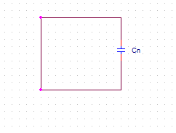

**Summary of Capacitors connected in Series and Parallel:**

It is concluded that equivalent capacitance is reverse of equivalent resistance. When the capacitors are in series the total capacitance is the inverse of the sum of individual capacitance.

On the other hand when the capacitors are parallel it is also inverse behavior and equivalent capacitance is the sum of all individual capacitance..When capacitors are interconnected, their equivalent capacitance is determined as follows: capacitors in series combine like resistors in parallel, and capacitors in parallel combine like resistors in series.

**Inductors in Series:**

If N inductors are connected in series, the equivalent inductance of the combination can be determined as follows.

v(t) = v1(t) + v2(t) + v3(t) +……+vN(t).

v(t) = L1di(t)/d(t) + L2di(t)/d(t) + L3di(t)/d(t) +…+Lndi(t)/d(t).

= Ls di(t)/d(t).

Ls = L1 + L2 + L3 +…Ln.

**Circuit Diagram:**

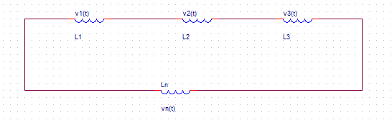

**Circuit Diagram of Equivalent Inductance in Series:**

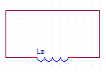

**Parallel Inductors in Parallel:**

Consider the circuit**,** which contains N parallel inductors. Using KCL, we can write

i(t) = i1(t) + i2(t) + i3(t) +….+ iN(t).

i(t) = [(1/Li) integration from T to To v(x) dx] +i(to)

1/Lp = 1/L1 + 1/L2 + 1/L3 +…+ 1/Ln.

**Circuit Diagram:**

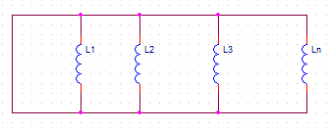

**Circuit Diagram of Equivalent Inductance in Parallel:**

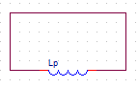

**Summary of Inductors connected in Series and Parallel:**

It means that equivalent inductance is same of equivalent resistance. When the inductors are in series the total inductance is the sum of individual inductance. On the other hand when the inductors are parallel it is the inverse of the sum of the individual inductance.

When inductors are interconnected, their equivalent inductance is determined as follows: inductors in series combine like resistors in series, and inductors in parallel combine like resistors in parallel.

**Energy Storing Elements:**

**Capacitor:**

Capacitor is an energy storing element. It stores energy in the form of Electric field between its two plates.Its two plates hold opposite charges and the separation between them creates an electric field. That's why a **capacitor stores energy**.

P(t) = v(t).i(t)

i(t) = Cdv(t)/d(t)

P(t) = C v(t) dv(t)/d(t)

W(t)= 1 /2 Cv^2 (t) J

W(t) =1/2 q^t/C.

**Inductors:**

Inductor is an energy storing element. It saves energy in the form of magnetic field.Because **inductors store** the kinetic **energy** of moving electrons in the form of a magnetic field, they behave quite differently than resistors (which simply dissipate **energy** in the form of heat) in a circuit. **Energy storage** in an I**nductor** is a function of the amount of current through it.Inductor consists of coils which are tightly bound in round shape of wire. Inductors also have effect of magnetic field which can be used to store the energy.

p(t) = v(t)i(t)

v(t) = Ldi(t)/d(t)

v(t) =[Ldi(t)/dt] i(t)

wL(t) = 1/2 Li^2 (t) J

**Summary:**

* We discuss about Capacitors and Inductors and how they are solved in different circuits. Capacitors in series are solved like resistors are solved in parallel and vice verse.

In Series: 1/Cq = 1/C1 + 1/C2 +1/C3 +…. + 1/Cn.

In Parallel: Ceq= C1 + C2 + C3+….+ Cn.

* Inductors are solved same as resistors are solved in both series and parallel combinations.

In Series: Leq = L1 + L2 +…. + Ln.

In Parallel: 1/Leq = 1/L1 + 1/L2 + 1/L3 +…+ 1/Ln.

* We also discuss about why Capacitor and Inductors store energy.
* Capacitor store energy in form of Electric field.
* Inductors store energy in form of Magnetic field.

**”**